Week 4
Spring REST using SpringBoot

Hands-on 1
Create a Spring Web Project using Maven

Steps Followed:
- Go to https://start.spring.io/
- Change Group as “com.cognizant”
- Change Artifact Id as “spring-learn”
- Select Spring Boot DevTools and Spring Web
- Create and download the project as zip
- Extract the zip in root folder to Eclipse Workspace
- Build the project using ‘mvn clean package
-Dhttp.proxyHost=proxy.cognizant.com -Dhttp.proxyPort=6050
-Dhttps.proxyHost=proxy.cognizant.com -Dhttps.proxyPort=6050
-Dhttp.proxyUser=123456’ command in command line
- Import the project in Eclipse "File > Import > Maven > Existing Maven Projects > Click Browse and select extracted folder > Finish"
- Include logs to verify if main() method of SpringLearnApplication. Run the SpringLearnApplication class.
CODE-SpringLearnApplication.java
package com.cognizant.spring_learn;

import org.slf4j.Logger;
import org.slf4j.LoggerFactory;
import org.springframework.boot.SpringApplication;
import org.springframework.boot.autoconfigure.SpringBootApplication;

@SpringBootApplication
public class SpringLearnApplication {

private static final Logger LOGGER = LoggerFactory.getLogger(SpringLearnApplication.class);

public static void main(String[] args) { LOGGER.info("START");
SpringApplication.run(SpringLearnApplication.class, args); LOGGER.info("END");
}
}

OUTPUT
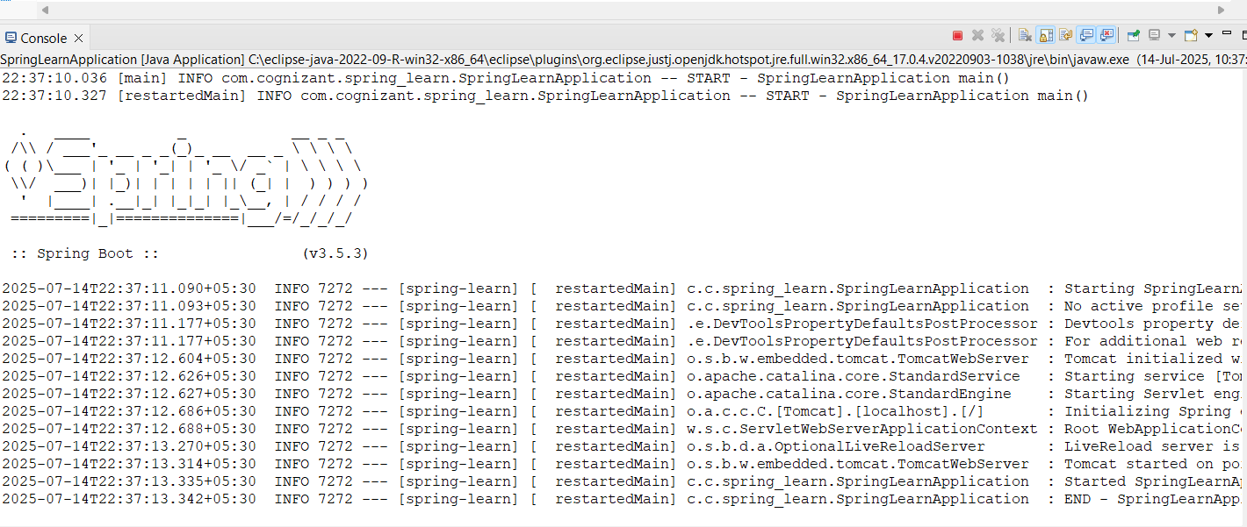

Hands-on 2
Spring Core – Load Country from Spring Configuration XML
Steps followed:

Created a Spring Boot project with Spring Web and DevTools. Created a Country class with a name property.

Added country.xml in src/main/resources and defined a Country bean.

Loaded the XML using ClassPathXmlApplicationContext in displayCountry() method.

Called displayCountry() from main() to print the loaded country.

- Country.java
package com.cognizant.spring_learn;

public class Country { private String name;
public Country() {} public String getName() {
return name;
}

public void setName(String name) { this.name = name;
}

@Override
public String toString() {
return "Country [name=" + name + "]";
}
}

- Country.xml
<?xml version="1.0" encoding="UTF-8"?>
<beans xmlns="http://www.springframework.org/schema/beans" xmlns:xsi="http://www.w3.org/2001/XMLSchema-instance" xsi:schemaLocation="http://www.springframework.org/schema/beans

https://www.springframework.org/schema/beans/spring-beans.xsd">

<bean id="country" class="com.cognizant.spring_learn.Country">
<property name="name" value="India" />
</bean>
</beans>

- SpringLearnApplication.java
package com.cognizant.spring_learn;

import org.slf4j.Logger;
import org.slf4j.LoggerFactory;
import org.springframework.boot.SpringApplication;
import org.springframework.boot.autoconfigure.SpringBootApplication; import org.springframework.context.ApplicationContext;
import org.springframework.context.support.ClassPathXmlApplicationContext;

@SpringBootApplication
public class SpringLearnApplication {

private static final Logger LOGGER = LoggerFactory.getLogger(SpringLearnApplication.class);

public static void main(String[] args) { LOGGER.info("START");
SpringApplication.run(SpringLearnApplication.class, args); displayCountry();
LOGGER.info("END");
}

public static void displayCountry() { ApplicationContext context = new
ClassPathXmlApplicationContext("country.xml");
Country country = context.getBean("country", Country.class);

System.out.println("Country Loaded: " + country); ((ClassPathXmlApplicationContext) context).close();
}
}

OUTPUT
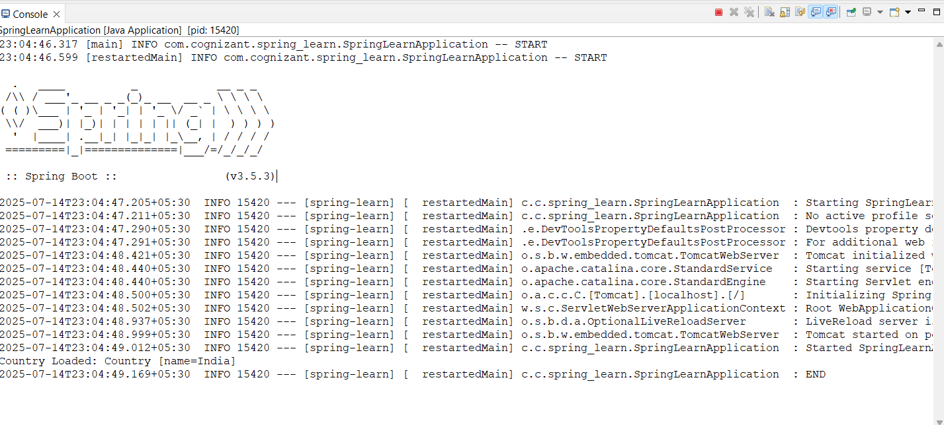
Hands-on 3
Hello World RESTful Web Service

Write a REST service in the spring learn application created earlier, that returns the text "Hello World!!" using Spring Web Framework. Refer details below:

Method: GET
URL: /hello
Controller: com.cognizant.spring-learn.controller.HelloController
Method Signature: public String sayHello()
Method Implementation: return hard coded string "Hello World!!"
Sample Request: http://localhost:8083/hello
Sample Response: Hello World!!

SOLUTION
Add the REST Controller (HelloController) HelloController.java

package com.cognizant.spring_learn.controller;

import org.slf4j.Logger;
import org.slf4j.LoggerFactory;
import org.springframework.web.bind.annotation.*;

@RestController
public class HelloController {

private static final Logger LOGGER = LoggerFactory.getLogger(HelloController.class);

@GetMapping("/hello") public String sayHello() {
LOGGER.info("START - sayHello()"); String response = "Hello World!!"; LOGGER.info("END - sayHello()"); return response;
}
}

OUTPUT
Console Output in Eclipse IDE


API Output in Web Browser


API Response in Postman
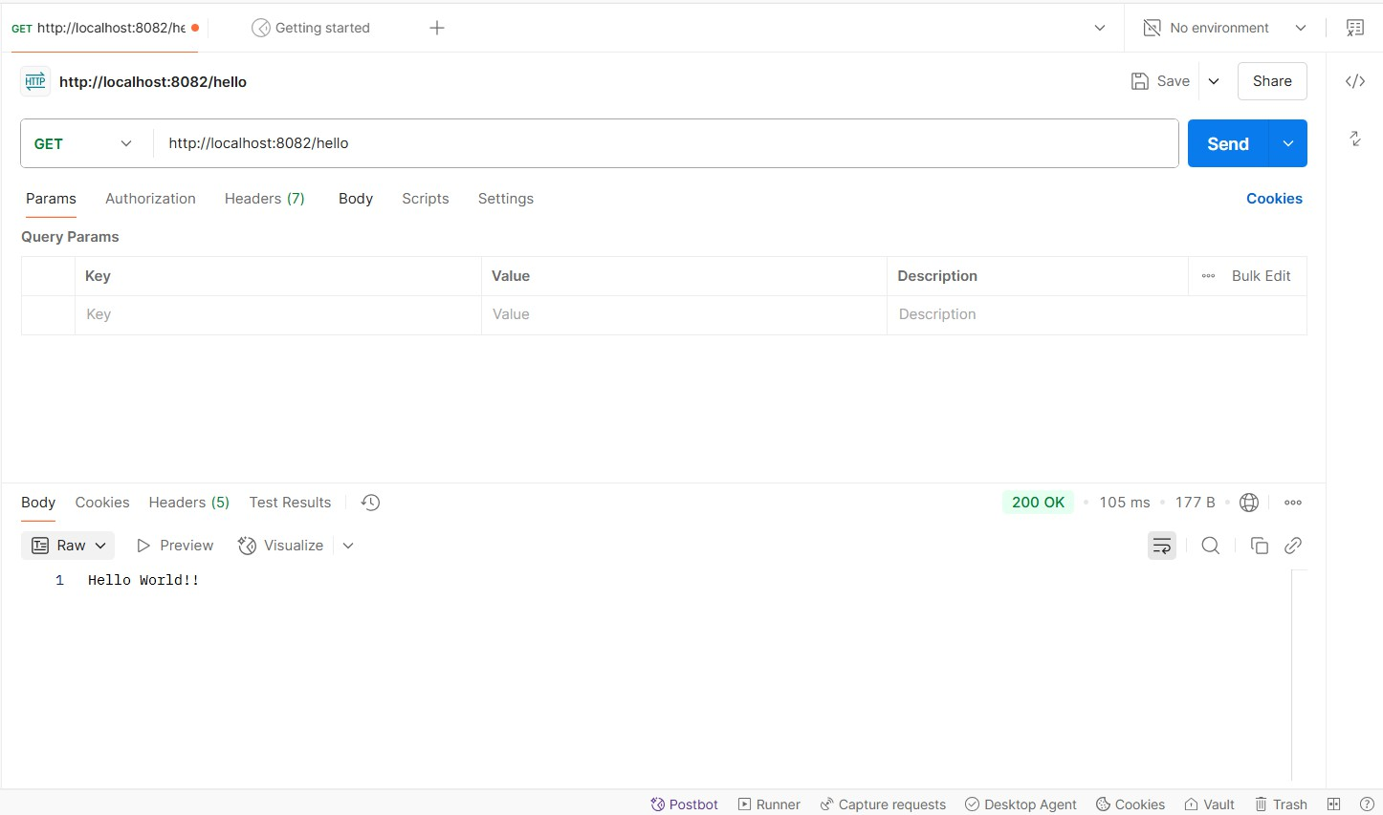

Hands-on 4
REST - Country Web Service

Write a REST service that returns India country details in the earlier created spring learn application.

URL: /country
Controller: com.cognizant.spring-learn.controller.CountryController
Method Annotation: @RequestMapping
Method Name: getCountryIndia()
Method Implementation: Load India bean from spring xml configuration and return
Sample Request: http://localhost:8083/country
Sample Response:
{
"code": "IN",
"name": "India"
}

SOLUTION
- Country.java – Model Class
package com.cognizant.spring_learn;

public class Country { private String code; private String name;

public String getCode() { return code;

}

public void setCode(String code) { this.code = code;
}

public String getName() { return name;
}

public void setName(String name) { this.name = name;
}

@Override
public String toString() {
return "Country [code=" + code + ", name=" + name + "]";
}
}

- Country.xml – Spring Configuration File
<?xml version="1.0" encoding="UTF-8"?>
<beans xmlns="http://www.springframework.org/schema/beans" xmlns:xsi="http://www.w3.org/2001/XMLSchema-instance" xsi:schemaLocation="http://www.springframework.org/schema/beans http://www.springframework.org/schema/beans/spring-beans.xsd">

<bean id="in" class="com.cognizant.spring_learn.Country">
<property name="code" value="IN"/>
<property name="name" value="India"/>
</bean>
</beans>

- CountryController.java – Controller Class
package com.cognizant.spring_learn.controller;

import com.cognizant.spring_learn.Country; import org.slf4j.Logger;
import org.slf4j.LoggerFactory;
import org.springframework.context.ApplicationContext;
import org.springframework.context.support.ClassPathXmlApplicationContext; import org.springframework.web.bind.annotation.RequestMapping;
import org.springframework.web.bind.annotation.RestController;

@RestController
public class CountryController {

private static final Logger LOGGER = LoggerFactory.getLogger(CountryController.class);

@RequestMapping("/country") public Country getCountryIndia() {
LOGGER.info("START - getCountryIndia()"); ApplicationContext context = new
ClassPathXmlApplicationContext("country.xml"); Country country = (Country) context.getBean("in"); LOGGER.info("END - getCountryIndia()");
return country;
}
}

- SpringLearnApplication.java – Main Class
package com.cognizant.spring_learn; import org.slf4j.Logger;
import org.slf4j.LoggerFactory;

import org.springframework.boot.SpringApplication;
import org.springframework.boot.autoconfigure.SpringBootApplication;

@SpringBootApplication
public class SpringLearnApplication {

private static final Logger LOGGER = LoggerFactory.getLogger(SpringLearnApplication.class);

public static void main(String[] args) { LOGGER.info("START");
SpringApplication.run(SpringLearnApplication.class, args); LOGGER.info("END");
}
}

OUTPUT
Console Output in Eclipse IDE
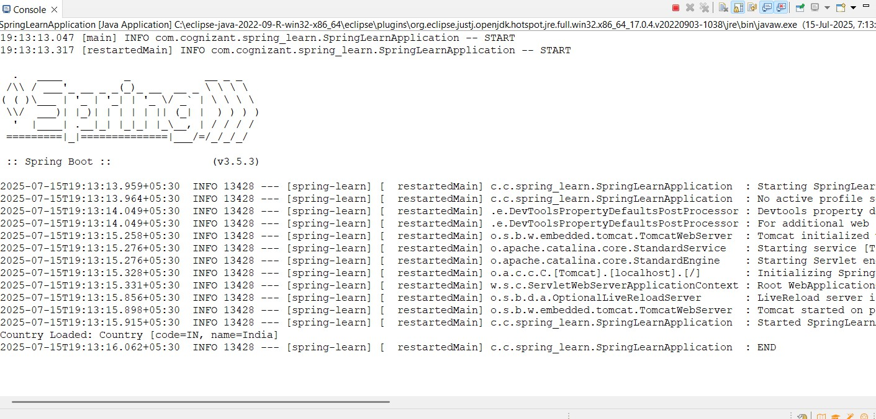

API Output in Web Browser

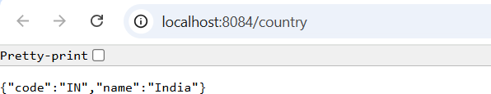

API Response in Postman
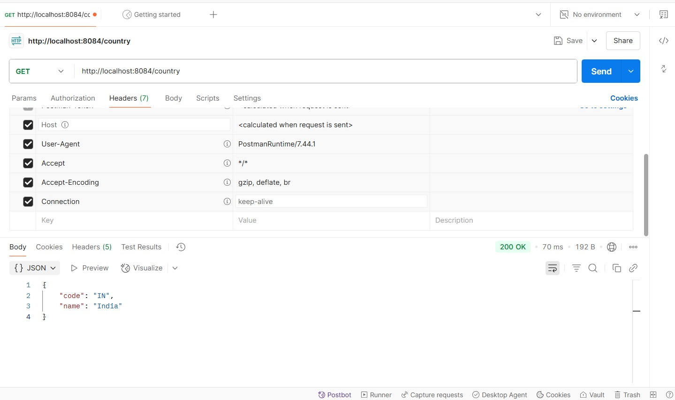

JWT Handson

Create authentication service that returns JWT
As part of first step of JWT process, the user credentials needs to be sent to authentication service request that generates and returns the JWT.

Ideally when the below curl command is executed that calls the new authentication service, the token should be responded. Kindly note that the

credentials are passed using -u option.

Request
curl -s -u user:pwd http://localhost:8090/authenticate

Response
{"token":"eyJhbGciOiJIUzI1NiJ9.eyJzdWIiOiJ1c2VyIiwiaWF0IjoxNTcwMzc5ND
c0LCJleHAiOjE1NzAzODA2NzR9.t3LRvlCV-hwKfoqZYlaVQqEUiBloWcWn0f t3tgv0dL0"}

This can be incorporated as three major steps:
- Create authentication controller and configure it in SecurityConfig
- Read Authorization header and decode the username and password
- Generate token based on the user retrieved in the previous step

SOLUTION
- Create authentication controller and configure it in SecurityConfig AuthenticationController.java
package com.cognizant.spring_learn.controller; import org.slf4j.Logger;
import org.slf4j.LoggerFactory;
import org.springframework.web.bind.annotation.GetMapping; import org.springframework.web.bind.annotation.RequestHeader; import org.springframework.web.bind.annotation.RestController;

import java.util.HashMap; import java.util.Map;

@RestController
public class AuthenticationController { private static final Logger LOGGER =
LoggerFactory.getLogger(AuthenticationController.class); @GetMapping("/authenticate")
public Map<String, String> authenticate(@RequestHeader("Authorization") String authHeader) {
LOGGER.info("START - /authenticate"); LOGGER.debug("Authorization Header: {}", authHeader);

Map<String, String> map = new HashMap<>(); map.put("token", "");

LOGGER.info("END - /authenticate"); return map;
}
}

SecurityConfig.java
package com.cognizant.spring_learn.config;

import org.springframework.context.annotation.Bean;
import org.springframework.context.annotation.Configuration;
import org.springframework.security.config.annotation.web.builders.HttpSecurity; import org.springframework.security.core.userdetails.User;
import org.springframework.security.core.userdetails.UserDetails;
import org.springframework.security.provisioning.InMemoryUserDetailsManager; import org.springframework.security.web.SecurityFilterChain;

@Configuration
public class SecurityConfig { @Bean
public SecurityFilterChain filterChain(HttpSecurity http) throws Exception { http
.csrf().disable()
.authorizeHttpRequests()
.requestMatchers("/countries").hasRole("USER")
.requestMatchers("/authenticate").hasAnyRole("USER", "ADMIN")
.anyRequest().authenticated()
.and()
.httpBasic();

return http.build();

}
@Bean
public InMemoryUserDetailsManager userDetailsService() { UserDetails user = User.withDefaultPasswordEncoder()
.username("user")
.password("pwd")
.roles("USER")
.build();

return new InMemoryUserDetailsManager(user);
}
}
Console Output in Eclipse IDE
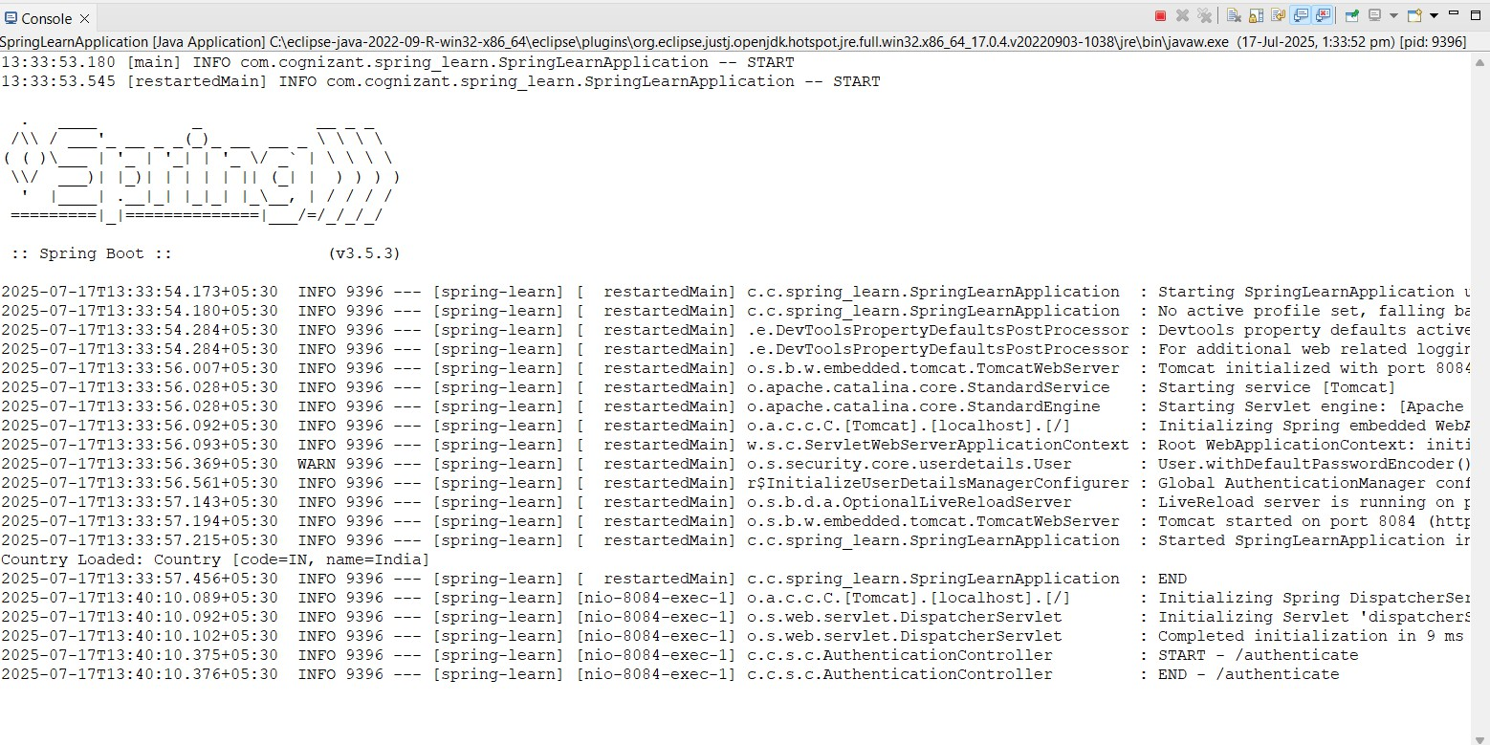

API Response in Terminal
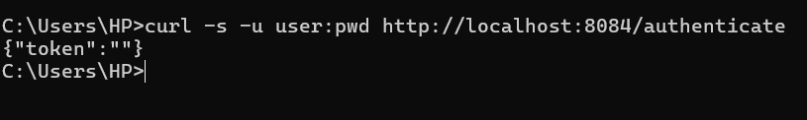

- Read Authorization header and decode the username and password AuthenticationController.java
package com.cognizant.spring_learn.controller; import java.nio.charset.StandardCharsets; import java.util.Date;
import java.util.HashMap; import java.util.Map;
import javax.crypto.SecretKey; import org.slf4j.Logger;
import org.slf4j.LoggerFactory;
import org.springframework.beans.factory.annotation.Value; import org.springframework.security.core.Authentication;
import org.springframework.security.core.context.SecurityContextHolder; import org.springframework.web.bind.annotation.GetMapping;
import org.springframework.web.bind.annotation.RestController; import io.jsonwebtoken.Jwts;
import io.jsonwebtoken.JwtBuilder;

import io.jsonwebtoken.SignatureAlgorithm; import io.jsonwebtoken.security.Keys; @RestController
public class AuthenticationController {
private static final Logger LOGGER = LoggerFactory.getLogger(AuthenticationController.class);
@Value("${jwt.secret}") private String secretKey; @GetMapping("/authenticate")
public Map<String, String> authenticate() {
LOGGER.info("START - /authenticate"); Authentication authentication =
SecurityContextHolder.getContext().getAuthentication(); String user = authentication.getName(); LOGGER.info("Authenticated user: {}", user); String token = generateJwt(user); LOGGER.info("Generated Token: {}", token); Map<String, String> response = new HashMap<>(); response.put("token", token);
LOGGER.info("END - /authenticate"); return response;
}
private String generateJwt(String user) {

SecretKey key = Keys.hmacShaKeyFor(secretKey.getBytes(StandardCharsets.UTF_8));
JwtBuilder builder = Jwts.builder()
.setSubject(user)
.setIssuedAt(new Date())
.setExpiration(new Date(System.currentTimeMillis() + 20 * 60 * 1000))
.signWith(key, SignatureAlgorithm.HS256);

return builder.compact();
}
}
SecurityConfig.java
package com.cognizant.spring_learn.config;
import org.springframework.context.annotation.Bean;
import org.springframework.context.annotation.Configuration;
import org.springframework.security.config.annotation.web.builders.HttpSecurity; import org.springframework.security.core.userdetails.User;
import org.springframework.security.core.userdetails.UserDetails;
import org.springframework.security.provisioning.InMemoryUserDetailsManager; import org.springframework.security.web.SecurityFilterChain;

@Configuration
public class SecurityConfig {

@Bean
public SecurityFilterChain filterChain(HttpSecurity http) throws Exception { http
.csrf().disable()
.authorizeHttpRequests()
.requestMatchers("/countries").hasRole("USER")
.requestMatchers("/authenticate").hasAnyRole("USER", "ADMIN")
.anyRequest().authenticated()
.and()
.httpBasic();

return http.build();
}

@Bean
public InMemoryUserDetailsManager userDetailsService() { UserDetails user = User.withDefaultPasswordEncoder()
.username("user")
.password("pwd")
.roles("USER")
.build();

return new InMemoryUserDetailsManager(user);
}
}

OUTPUT

- Generate token based on the user SOLUTION
pom.xml
<?xml version="1.0" encoding="UTF-8"?>
<project xmlns="http://maven.apache.org/POM/4.0.0" xmlns:xsi="http://www.w3.org/2001/XMLSchema-instance" xsi:schemaLocation="http://maven.apache.org/POM/4.0.0
https://maven.apache.org/xsd/maven-4.0.0.xsd">
<modelVersion>4.0.0</modelVersion>
<parent>
<groupId>org.springframework.boot</groupId>

<artifactId>spring-boot-starter-parent</artifactId>
<version>3.5.3</version>
<relativePath/>
</parent>

<groupId>com.cognizant</groupId>
<artifactId>spring-learn</artifactId>
<version>0.0.1-SNAPSHOT</version>
<name>spring-learn</name>
<description>Demo project for Spring Boot</description>
<properties>
<java.version>17</java.version>
</properties>
<dependencies>
<dependency>
<groupId>org.springframework.boot</groupId>
<artifactId>spring-boot-starter-web</artifactId>
</dependency>
<dependency>
<groupId>org.springframework.boot</groupId>
<artifactId>spring-boot-devtools</artifactId>

<scope>runtime</scope>
<optional>true</optional>
</dependency>
<dependency>
<groupId>org.springframework.boot</groupId>
<artifactId>spring-boot-starter-test</artifactId>
<scope>test</scope>
</dependency>
<dependency>
<groupId>org.springframework.boot</groupId>
<artifactId>spring-boot-starter-security</artifactId>
</dependency>
<dependency>
<groupId>io.jsonwebtoken</groupId>
<artifactId>jjwt-api</artifactId>
<version>0.11.5</version>
</dependency>
<dependency>
<groupId>io.jsonwebtoken</groupId>
<artifactId>jjwt-impl</artifactId>
<version>0.11.5</version>

<scope>runtime</scope>
</dependency>
<dependency>
<groupId>io.jsonwebtoken</groupId>
<artifactId>jjwt-jackson</artifactId>
<version>0.11.5</version>
<scope>runtime</scope>
</dependency>
</dependencies>
<build>
<plugins>
<plugin>
<groupId>org.springframework.boot</groupId>
<artifactId>spring-boot-maven-plugin</artifactId>
</plugin>
</plugins>
</build>
</project>

AuthenticationController.java
package com.cognizant.spring_learn.controller;

import com.cognizant.spring_learn.model.JwtRequest; import com.cognizant.spring_learn.model.JwtResponse; import com.cognizant.spring_learn.util.JwtUtil;
import org.springframework.http.ResponseEntity; import org.springframework.web.bind.annotation.*; @RestController
public class AuthenticationController { @GetMapping("/test")
public String test() {
return "API is working!";
}
@PostMapping("/authenticate")
public ResponseEntity<?> createAuthenticationToken(@RequestBody JwtRequest jwtRequest) {
if ("admin".equals(jwtRequest.getUsername()) && "admin123".equals(jwtRequest.getPassword())) {
String token = JwtUtil.generateToken(jwtRequest.getUsername()); return ResponseEntity.ok(new JwtResponse(token));
} else {
return ResponseEntity.status(401).body("Invalid credentials");
}
}
}

JwtRequest.java
package com.cognizant.spring_learn.model;

public class JwtRequest { private String username; private String password;

public JwtRequest() {}

public JwtRequest(String username, String password) { this.username = username;
this.password = password;
}
public String getUsername() { return username;
}
public void setUsername(String username) { this.username = username;
}
public String getPassword() { return password;
}

public void setPassword(String password) { this.password = password;
}
}
JwtResponse.java
package com.cognizant.spring_learn.model;

public class JwtResponse { private String token;
public JwtResponse(String token) { this.token = token;
}
public String getToken() { return token;
}
public void setToken(String token) { this.token = token;
}
}
JwtUtil.java
package com.cognizant.spring_learn.util;

import io.jsonwebtoken.Jwts;
import io.jsonwebtoken.SignatureAlgorithm; import java.util.Date;
public class JwtUtil {
private static final String SECRET_KEY = "secretkey"; public static String generateToken(String username) {
return Jwts.builder()
.setSubject(username)
.setIssuedAt(new Date())
.setExpiration(new Date(System.currentTimeMillis() + 1200000))
.signWith(SignatureAlgorithm.HS256, SECRET_KEY)
.compact();
}
}
OUTPUT

